**Business Plan**

**MyCloak**

**Date: 26/03/2019**



Ryan O’Toole – x17409626

Aaron Fleming – x17441516

Cian Larkin – x17453136

Carl Flynn – 17347726

Matthew Kearns – x17492632

**MyCloak,**

**Business Plan.**

**CONTENTS:**

**SECTION 1 EXECUTIVE SUMMARY.**

**SECTION 2 INTRODUCTION.**

**SECTION 3 MARKET.**

**Overview**

**Trend**

**Size and potential**

**Competition**

**Customers**

**S.W.O.T. Analysis**

**SECTION 4 MARKET STRATEGY.**

**Objectives**

**Product**

**Price**

**Place**

**Promotion**

**SECTION 5 ORGANISATION / MANAGEMENT.**

**Management Overview**

**Staff Requirement**

**SECTION 6 PRODUCTION AND OPERATIONS.**

**Premises**

**Plant and Equipment**

**Operations Overview**

**SECTION 7 COSTINGS & FINANCE**

**Financial Assumptions**

**Sales**

**Detailed job overview**

**Capital grant**

**Capital expenditure**

**Funding**

**Statement of profit and loss**

**Section 1:**

Executive Summary

Company Name: MyCloak.,

Address: N Wall Quay

North Dock Dublin

Dublin 1.

Telephone: 01- 260 0030

Fax: 01- 260 0301

Co. Registration No.: 1094765XX

V.A.T. No.: IE 200030000E

Bank: Bank of Ireland,

Bank Centre,

MyCloak is an android app created by A. Fleming, C. Larkin, M. Kearns R. O’Toole and C. Flynn that will be used by nightclubs for their cloakrooms. You use the app instead of a raffle ticket when you have given your jacket in. After you pay, you’ll be given a QR code on the app which you will use to collect the jacket, you can also give your name in case you lose your phone.

The company’s objectives into the future are:

* To have 15 clubs and events registered by year 1.
* To increase the number of clubs registered to 30 by the end of year 2.
* To expand to other areas that use a cloakroom that could benefit from this app.

**Section 2:**

Introduction:

MyCloak is a recently formed company that engages in cloak room ticketing systems for mobile applications primarily focusing on ticketing for bars and nightclubs at the moment but we hope to expand into other areas moving forward.

We came up with the idea from our own bad experiences with nightclub and bar ticketing systems as we have lost them on occasion and have seen friends and other people frequently lose or misplace tickets as they are small and easy to lose. We identified that there has been no innovation or automation in this area recently and there is room for improvement and as we have a stake in the business as it affects us and we are part of our target market, we thought who better to make a difference.

Our main application has several main features that make up the system. The app will comprise of the following features:

1. A QR code generator – This is what is scanned by the bar/nightclub worker to retrieve the customers jacket
2. Scan feature – This accesses the phones camera so that the worker can scan the code to retrieve the jacket
3. Zoom – So that the code can be enlarged if the worker is having problems scanning

A full technical report can be viewed if requested

**Grant Assistance**

We have received five $100 Microsoft Azure vouchers from the National College of Ireland but we have also applied for County Enterprise Board grants and we intend to apply for an Innovation Voucher worth up to five thousand Euro from Enterprise Ireland. This voucher can be used for new product development, new business model development, new service delivery, new service development, training in innovation management and a technology/innovation audit. The college operates as a knowledge provider so we will be undergoing the application process soon.

**Section 3:**

Marketing

**The Market**

MyCloak is an app designed for nightclubs in order for customers to easily collect their jackets when stored in a cloakroom.

**Overview**

The market for people storing their jackets in a cloakroom is shown in the example based on coppers nightclub below:

In 2011 Coppers nightclub made €4520 a week from their cloakroom alone. Based on these figures we believe that nightclubs would find the use of our app helpful in storing customers jackets.

**Size and potential**

Secondary desk research indicates that a large amount of money can be made which is shown by the amount of money that coppers alone makes from their cloakroom. Coppers made 217,000 euro in 2011 from their cloakroom this figure is based on the information gathered by the Irish examiner in that year.

**Competition**

When we first began work on creating MyCloak we conducted research on similar apps that nightclubs may use. after conducting this research, we realised that there was next to no other apps providing this service to nightclubs, so we decided that this market had great potential for profitability. After concluding that there were no other apps to compete against, we ruled that our only current competition is the old ticketing systems that nightclubs use. in order to compete with this, we made the design for our app simplistic and easy to use as we thought that this was our best way to market the app to potential buyers.

**Customers**

Our current potential customers are that of nightclubs that have a cloakroom and the customers that attend these nightclubs. We believe that this app will be extremely useful to nightclubs as it will allow them to easily keep track of how many coats they take in each night. The following is list of nightclubs that are popular in Dublin with a large number of customers each night. Based on our own experiences we decided that these nightclubs would be our best first targets to sell our app.

List of targeted nightclubs:

The Academy

O’Reillys

Diceys

Coppers

The Living Room

**SWOT Analysis**

**Strengths**

Each member of the management team has their own unique experiences in the workplace. We also have different fields of expertise which makes it possible for us each to run different parts of the business successfully. The promoters each have good time management based on completing assignments and projects as part of a group when we each studied in college. The company enjoys a favourable location in the city centre which makes it a prime location for targeting the huge number of potential nightclubs that are in Dublin.

**Weaknesses**

our main weakness would be that we have a very limited amount of capital to begin our company. This plan lists the sources that we intend to use in order to acquire additional funding that we can use in order to allow us to expand the business.

**Opportunities**

While the initial nightclubs that we have targeted are listed above we also intend to expand our target audience to other bars and nightclubs within our first year. We then hope to expand to various other events that use cloakrooms. In the long term based on the income and profitability of the app we also plan to market the app throughout the rest of the country and possibly abroad.

**Threats**

The main threat that we as a company face is from other app creators that may see our app and decide to make a competing app at a lower price, which in turn could turn our potential customers towards our competitors. Thereby allowing them to become a larger company and greater competition for us.

**Section 4:**

Market Strategy

In order to achieve our Sales Target outlined in our enclosed projections the following strategy has been encouraged:

Objectives**.**

* To achieve a profitability of 20% return on sales by year 1.
* To achieve a 60% share of the identified market by the end of year 2.
* To achieve a profitability of 70 % return on sales by year 2.
* To secure ISO 9000 accreditation in the short term.
* To secure IOS availability in the short term.
* To transition from entrepreneurial to managerial in the short term.
* Medium Term - to buy its own premises in the Dublin area.
* Long Term- expansion into our geographical market areas (large cities), and buy premises in some of them.
* To have 15 clubs and events registered by year 1.
* To increase the number of clubs registered to 30 by the end of year 2.

Product**.**

The product is android app that has set specifications, configurations and components that will be charged to the customer and updated only by ourselves, and sold as an update.

Price.

Currently apps similar to MyCloak in terms of being new to the market with intent of maximizing brand name and market share as soon as possible, offer a free download and in app purchases. We are approaching our pricing in this way as the app will be free to download but the database access to the nightclub will be sold, offering them valuable information on their own market of nightclub users.

Place.

Selling will be approached on a direct basic with face to face meeting with our targeted customers at an arranged location. This function will be carried out by our Sales and Marketing Director, who will be out in the market for the majority of his work.

**Section 5:**

Organisation/Management

**The Organisation**

MyCloak is a private limited company owned in equal parts by the five promoters. A copy of the certificate of incorporation is appended and a copy of the Memorandum and Articles of Association will be made available to the bank in normal course.

**Management Overview**

Key Staff and their activities

**Mr. Carl Flynn**

Owner

Marketing Director

12 years' experience in Marketing

**Mr. Cian Larkin**

Owner

Lead Programmer

12 years' experience in Computer Science

**Mr. Aaron Fleming**

Owner

Business Director

9 years' experience in Business Management

**Mr. Ryan O’Toole**

Owner

Systems Administrator

11 years' experience in IT Systems

**Mr. Matthew Kearns**

Owner

Database Administrator

10 years' experience in Database Systems

Full CV for each owner attached in the appendices

**Staff Requirement**

Each owner plays a vital role in the company and has their own specific area of expertise and every owner carries out their job well with their given experience however as we anticipate the business growing we will need to hire more employees, we anticipate having to hire an extra two staff members in year two and an additional 3-4 in year three depending on the company's growth.

**Section 6:**

**PRODUCTION AND OPERATIONS**

**Premises:**

For its opening years of operation myCloak have agreed to lease an Office Block located in the City Centre. The location of the office block that will be occupied by the myCloak management is N Wall Quay North Dock Dublin D D1.

The office block comprises of two offices and one control room where the database can be accessed, and the application can be modified, or enhancements can be made to it.

This office block will be sufficient for the first few years of operation but as an organization we have a long-term goal of expanding and buying our own premises in which we can operate out of.

The office block provides all of the essentials such as bathrooms, breakrooms and a canteen although will need some modifications to allow for extra spacing so that all the necessary equipment.

**Productions/Operations:**

When taking on new clientele the process goes as follows:

When we approach an event such as a nightclub or any other events, we promote our product to the client displaying how the application is used and how the app could assist them and aid them in the future.

If the client is satisfied and decides to go ahead with the usage of our application our installation team will go to the venue and set up the database so that the application will be ready for use by customers.

The staff of the venue will be shown how to use the application and how to access data from the database such as customers names and hanger numbers. The staff will be shown how to correctly scan the QR codes and access the data in the QR codes.

The coat collection process should be completed as follows.

1. Customer pays the cloakroom their entry fee to leave their coat for the night
2. Staff will then give the client the hangar number in which their coat is hung up on
3. The customer enters their name, phone number and their hangar number into the application and a QR code is then generated
4. At the end of the night the customer will give their QR code to the staff of the cloakroom to be scanned and their hangar number will be displayed with their name once the QR code is scanned
5. Should the customers phone die or go missing the staff will be able to enter the customers details into the database and discover what hangar the customers coat is hung up on.

**Equipment:**

To carry out tasks and to ensure we can maintain the application and ensure the application is running sufficiently there are several pieces of equipment necessary so this can happen.

The equipment required would be:

* 5 Monitors
* 5 Key boards
* 5 Computers
* 2 HP laserpacket printer
* Desk Chairs
* Desks
* 2 Office phones

**Insurance:**

The owners of myCloak decided to purchase insurance for their employees and equipment. Items such as Employer liability, Public Liability, Fire and All Perils insurance etc.

**Quality Control:**

When the application is being implemented into the venue, we will run numerous tests when installing the system. This is to ensure the application is working correctly.

When the installation team go to the venue they will conduct tests such as making sure the QR codes are being created, scanning correctly and the data is being sent to the database.

**Section 7:**

**COSTINGS & FINANCE**

**Assumptions to the Financial Projections**

The final projections for the organizations first two years of operations can be located in the appendices section. The Financial Projections will forecast future financial outcomes for the company such as revenues and expenses. The financial projections include a sales forecast, an expenses budget and a statement of profit and loss.

**Sales**

Based on our extensive market research we formed our projected sales for the first and second year by aiming to take in fifteen customers in our first year of operation and expanding and doubling this figure in our second year of operation.

From our estimations we expect to receive ten thousand euro per annum from each venue our application is in use. With our monthly fee of five hundred euro and the additional two percent of all sales made by the nightclub or event these are the figures that were calculated for the sales of the first two years of the company. These figures are based off Coppers Nightclub and Diceys Club.

In our first year we plan on taking on a total of fifteen clients, from our calculations we have gained an estimate that we will average at least €10,000 from each of these clients.

For our second year we hope to expand our business and double our clientele base. We hope to go from fifteen clients to a total of thirty clients.

Year 1: €10,000 x 15 = €150,000

Year 2: €15,000 x 30 = €300,000

**Expenses**

For the first year of operation the management team forecasted all of the total expenses that would be made throughout the year. The expenses for the first year of the company’s running is as follows:

• Wages

• Marketing

• Equipment

• Enhancements

• Building Rent

These figures can be seen in the diagram below.

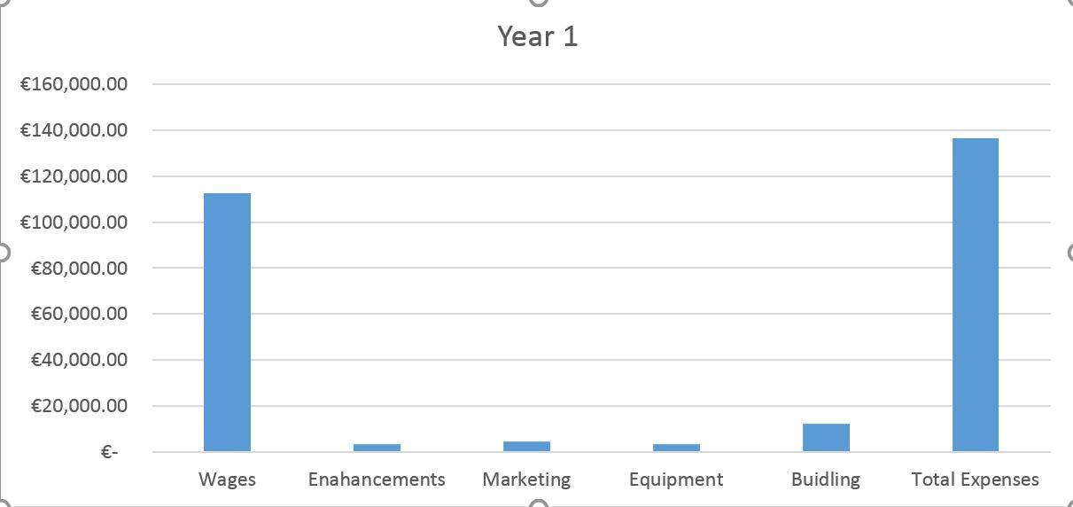

**Detailed Job Costing Overview**

The full cost of the application and the implementation of the application to the nightclub such as the installation of the app and the database being set up on the Nightclub or events systems.

For every venue we install the application to the cost for this will be as follows:

App Installation – Free

Database set up – Free

Monthly Fee - €500

Further fees – 2% of all future earnings

The venue will not be charged an installation fee but will instead have to pay a fee of €500 monthly as well as a further 2% of the earnings made whilst using the application for their venue.

**Capital Grant**

From meeting with Enterprise Ireland and discussing our business, displaying how the application would work and how the organization would earn revenue from the application we were permitted a startup fund from Enterprise Ireland for a total of €12,000.

**Capital Expenditure**

For the operations of the organizations we required an office block in order to conduct our work and complete tasks within the business. We decided to lease a property costing us €1041.66 monthly and a total of 12,500 for the year. To complete tasks new equipment was necessary so a total of €3,500 was set aside from the money received from the grant and the loan from the bank in order to be able to purchase this equipment. Equipment such as new computers, monitors, desks and stationary items were amongst the items purchased.

**Funding:**

The funding received for the project in order to get the business in operation can be seen below

**Source of Funds**

Personal Funds € 3,000.00

Grant €12,000.00

Bank Loan €10,000.00

Microsoft allowance € 500.00

Total €25,500.00

**Use of Funds**

Enhancements € 3,500.00

Rent €12,500.00

Marketing € 4,500.00

Equipment € 3,500.00

Total €24,000.00

**Statement of Profit and Loss**

There are two diagrams that can be found in the appendices containing the statements of profit and loss for the first two years of the business’s operations

**Sensitivity Analysis**

A sensitivity analysis for the first year of the business has been included in the appendix section B of the document and showcases the following figures.

**Year 1 Sales – 10% Sales –20%**

**Cash Balance** €150,000 €135,000 €120,000

**Profit/(Loss)** €31,500 €18,375 €5,250

The following figures show that the organization would be able to operate with a shortfall of sales up to 20%. Anything more than a 20% shortfall in sales and the company would not receive enough revenue in order to properly function as a business meaning we would be operating at a loss.

**Appendices**

**Appendix A - Statement of Profit and Loss**

**Appendix B – Sensitivity Analysis**

**Appendix C – Promoters CVS**

**Appendix A**

Year 1

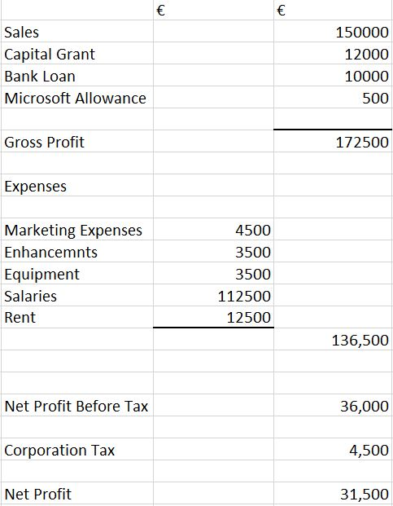

Year 2

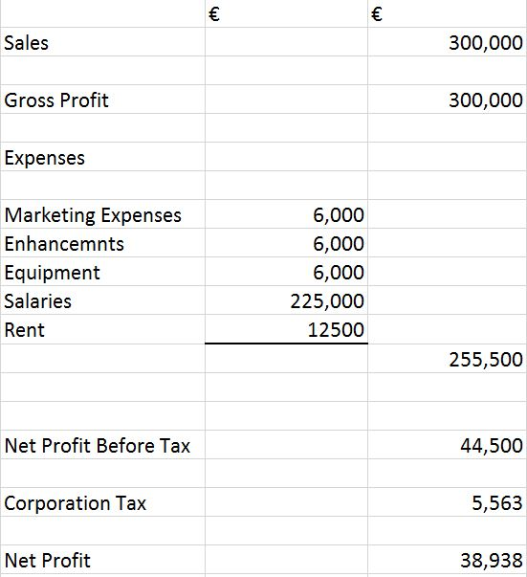

**Appendix B – Sensitivity Analysis**

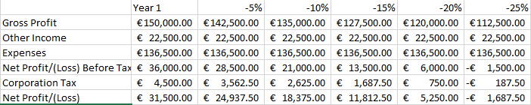

**Appendix C – Promoters CV’s**

# CURRICULUM VITAE

Ryan O’Toole

I was previously an NCI student completing both the higher certificate in business computing and the technology management course achieving a grade of a standard of 1.1. now working full time in myCloak as an IT Systems Admin and Co-Owner. I have proven ability to with work with people and am a strong team player with excellent interpersonal skills. I am self-motivated and like to work on my own initiative.

# ________________________________________________________________________________

# PERSONAL DETAILS

|  |  |
| --- | --- |
| **Address:** | 89 Grattan Lodge, Hole in the Wall, Dublin 13. |
| **Mobile:** | 085 845 9841 |
| **Email:** | [Ryanotoole6@gmail.com](mailto:Ryanotoole6@gmail.com) |

# ________________________________________________________________________________

# EDUCATION

|  |  |
| --- | --- |
| 2003 – 2007 | Scoil Bhríde Primary School, Donaghmede, Dublin 13 |
| 2007 – 2011 | Holy Trinity School, Donaghmede, Dublin 13 |
| 2011 - 2015 | St. Paul’s College, Raheny, Dublin 5 |
| 2015 -2017 | Higher Certificate in Business Computing NCI |
| 2017-2019 | Technology Management NCI |

# WORK EXPERIENCE

|  |  |
| --- | --- |
| **Irish Life, Dublin** |  |
| **I.T Systems Administrator** |  |
|  |  |

As an I.T systems administrator my roles consisted of ensuring the IT servers were maintained and the infrastructure was monitored daily, install and configure new and existing infrastructure. I was heavily involved with a lot of projects that took place within the IT sector of Irish Life.

|  |  |  |  |  |  |  |  |
| --- | --- | --- | --- | --- | --- | --- | --- |
| |  |  | | --- | --- | | **SuperValu, Sutton** |  | | **Team Leader** |  | |  |  |  * Team leader in Musgrave, SuperValu in Sutton. My duties include merchandising for all stock, placing orders and checking in deliveries, completing end of night reports, and providing customer service. As well as this I instruct staff on what their duties for the day are and give guidance if any colleagues are unsure on what tasks must be completed. |  |

|  |  |
| --- | --- |
|  |  |
| **Academic Registry, Trinity College Dublin**  **Part-time Executive Officer** |  |

* Part time Executive Officer. I was employed for three weeks during as a member of the Academic Registry team responsible for registering over 6,000 Trinity College students. My role included validating registration information and identification, generating student cards and responding general enquiries from the students.

|  |  |
| --- | --- |
| **FBD Insurance plc** |  |
| **Work placement** |  |

* During my work placement I joined the IT ecommerce team and had responsibility for testing the changes for the NoNonsense.ie car quotes on the website. I worked for two weeks at FBD and during my time at the company learned about car insurance and IT System Testing.

________________________________________________________________________________ HOBBIES AND ACHIEVEMENTS

* Member of Suttonians Rugby Club – Winners league 2016,2017,2018 and cup 2016,2018.
* Member of Trinity Football Club – Winners NDSL under 18’s A league.
* Player of the year for Trinity Football Club for three consecutive seasons
* Member of Slender Health Gym.
* Winner FBD 2013,2014 Coder DoJo Programmer of the Year award.

# ________________________________________________________________________________ REFEREES

|  |  |
| --- | --- |
| Ms. Deborah Hand  Information Technology  Irish Life  Co. Dublin    Title: Head of I.T  Tel.: 086 824 6441 | Mr. Johnathan Lynch  Academic Registry  Trinity College Dublin  Dublin    Title: Managing Executive Officer  Tel.: 087 963 1344 |

**Carl Flynn**

**Mobile:** 0872658952

**E-mail:** [Carlflynn1@outlook.com](mailto:Carlflynn1@outlook.com)

**Personal Statement**

Currently employed as head of marketing at MyCloak, have 12 years’ experience after attending the National College of Ireland studying a BSHC in Marketing Practice and formerly employed part time as a catering assistant in Deutsche Bank, East Point Business Park. Have experience working in a team from employment in the North Star Hotel and The Turks Head as well as my current employment and from working on group assignments during tenure at the National College of Ireland, very independent and capable worker and work extremely well under pressure

**Employment**

**Assistant Secretary**

St. Joseph’s Co-Ed Primary School, East Wall Road

**Tasks Involved:** Assisted the secretary with various tasks throughout the school including; taking calls, replying to e-mails, printing, photocopying, etc.

**Office Worker**

Dublin City Council South Central Area Office, Marrowbone Lane, Dublin 8

**Tasks Involved:** Took calls for the office, created a property database using Excel, Visited various community centres and projects throughout the area

**Bartender**

Turks Head Bar, 27 Parliament St, Temple Bar, Dublin 2

**Tasks Involved:** Serve food, serve drinks, clean tables down, change kegs, maintain stock levels, remove bins, collect glasses, work in nightclub on busy nights, clean outside and clean bar at the end of the night

**Project Manager**

Deutsche Bank, Pinnacle 2, East Point Business Park, Fairview, Dublin 3

**Tasks Involved:** Managing project teams, dividing the work, setting goals, motivating staff.

**Marketing Department Member**

Citi Bank, North Wall Quay, Dublin 1

**Tasks Involved:** Worked on ways to market Citi group to an international audience and keep up with consumer interests and adjust our marketing campaigns to match consumer trends

**Education**

* St. Josephs Co- Ed, East Wall, Dublin 3
* St. Josephs CBS, Fairview, Dublin 3
* National College of Ireland, Mayor Street, Dublin 1

**Achievements**

* Voted class representative for college course 1st and 2nd year.
* Course Leader in Gaeltacht.

**Interests**

* Sport
* Travelling
* Music

**Matthew Kearns**

**Personal Statement**

Currently employed as head of Database Administration at MyCloak, have 10 years’ experience after attending the National College of Ireland studying a BSHC in Computing and formerly employed part time as a store assistant with Supervalu

**Employment**

**Operations**

Supervalu, Aston Quay, Dublin 2

**Tasks Involved:** Taking in deliveries, operating heavy machinery, manual handling, organising stock rooms, putting stock out on floor, cleaning, stocking paper bags, removing rubbish, moved store equipment, member of fire safety team

**Web Developer**

Free lance

**Tasks involved:** worked on the database side of developing websites

**Database Operator**

Citi Bank, North Wall Quay, Dublin 1

**Tasks Involved:** Worked on customer databases to make sure all information was sorted and up to date as well as working on database security in compliance with GDPR guidelines

**Education**

* St. Laurence O’Tooles, Northwall, Dublin 1
* St. Josephs CBS, Fairview, Dublin 3
* National College of Ireland, Mayor Street, Dublin 1

**Achievements**

* Won coder of the year in 2nd year of college
* Helped develop the college website in 4th year

**Interests**

* Sport
* Travelling
* Music

Aaron Fleming

Mobile: 0851456467

Email: [aaronfleming58@gmail.com](mailto:aaronfleming98@gmail.com)

**Personal Statement**

Currently employed as the business director and co-owner of MyCloak, have 9 years’ experience in a number of different workplaces after previously studying higher certificate in business and computing in the National College of Ireland. I have experience working as part of a group under a set time period during a number of different projects as a student in NCI but also have the ability to work independently and under pressure.

**Work Experience**

**SMC Print and Design**

Operations Manager

**Tasks involved:** overseeing the day to day running of the business and ensuring that work is completed in a timely manner and of a good quality. Worked under pressure in order to ensure that customers received their orders when expected.

**Marks and Spencer’s**

Sales Assistant

**Tasks involved:** packing shelfs, manual handling training and ensuring that customers were satisfied with their experience in the store.

**Paddy Power**

IT systems administrator

**Tasks involved:** ensuring servers were maintained and running correctly on a daily basis. Managing and updating the network security of the company and overseeing data storage and retrieval systems.

**Education**

· St. Josephs Co- Ed, East Wall, Dublin 3

· St. Josephs CBS, Fairview, Dublin 3

· National College of Ireland, Mayor Street, Dublin 1

**Hobbies and Achievements**

* Completed higher certificate of business and computing in NCI
* Member of O’Tooles GAA club

**References available on request**

Cian Larkin

Mobile: 0851490463

Email: [cianlarkin1@gmail.com](mailto:cianlarkin1@gmail.com)

**Personal Statement**

Currently employed as the head of programming and co-owner of MyCloak, have 12 years’ experience in a number of different workplaces after previously studying a BSHC in computing in the National College of Ireland.

**Work Experience**

**Sales Manager**

Cineworld, The Parnell Centre, Parnell St, Dublin

**Tasks Involved:** improving yearly sales for the business, engaging with customers, motivating staff to perform to the highest level.

**Web Developer**

Google Building Gordon House, 4 Barrow St, Dublin

**Tasks Involved:** Worked on various aspects of the website, monitored performance levels, came up with innovative ideas.

**Software engineer**

Ebay Atrium Building, Old Navan Road Blanchardstown Dublin 15

**Tasks Involved:** carried out testing of products, coding using multiple software's and languages

**Education**

• St. Josephs primary school, Fairview, Dublin 3

• St. Josephs CBS, Fairview, Dublin 3

• National College of Ireland, Mayor Street, Dublin 1

**Hobbies and Achievements**

* Completed BSHC in computing in NCI

**References available on request**